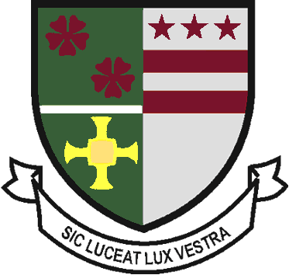
St Robert of Newminster

Catholic School and
Sixth Form College
Biddick Lane, Washington, Tyne & Wear. NE38 8AF
Tel: (0191) 561 3810 Fax: (0191) 415 3801
Head Teacher: Mr D. Juric Chair of Governors: Mr G Moorhouse
Email: sixthform@strobertofnewminster.co.uk

SIXTH FORM LEARNING CONTRACT 2019 -20

St Robert of Newminster Sixth Form College is committed to provide the highest quality of education and to offer opportunities to students who have the ambition, motivation and desire to “live life to the full”. This education will be based on a partnership with parents/ carers and the individual student. This partnership of shared values and beliefs, will be challenging and engaging.

Our aim is to develop confident young people, capable of independent learning, ready and wiling to operate as responsible and effective members of the community and equipped for the challenges of the 21st Century.

The Sixth Form learning Contract is a reminder to all the stakeholders in a students education (Parents/ Carers, College and Student) of their individual and collective responsibilities. It is essential that students do their best to ensure their responsibilities are met; this will enable them to develop their full potential both academically and as young adults.

The privilege of joining St Robert of Newminster Sixth Form brings with it both rights and responsibilities. You will become influential role models within the whole School community which will bring with it constraints and benefits. You must accept this as part of the package of being a sixth form student and remember that support and understanding does not conflict with the application and enforcement of rules. Where a student fails to meet the terms of this agreement there will be a range of responses including verbal and written warnings, and ultimately, a review of the right of the student to remain in the Sixth Form.

Mr D Bayne
Head of Sixth Form College

St Robert of Newminster Sixth Form Learning Agreement

As a student in post 16 education at St Robert of Newminster Catholic School & Sixth Form College I agree to:

- Follow the sixth form uniform code.
- Attend all lessons, registrations periods, pastoral lessons, independent study periods and assemblies.
- Be punctual to all of the above.
- Work to the best of my ability and complete work set by the given deadline.
- Respect the right of other students to learn in lessons and when using other sixth form facilities. Behave in a mature and responsible manner, recognising that I am a role model for students in years 7-11.
- Not to engage in any paid work during sixth form hours and limit part time work to 9 hours per week.
- Ensure medical/dental appointments, driving lessons are not taken during the school day.
- Remain on site between 08.50 and 15.20.
- Follow college no smoking policy and not smoke within the vicinity of the college.

We ask parents/carers to:
- Support the sixth form through the implementation of the Learning Agreement.
- Notify the school of any absences by telephone by 08.55am for each day of absence.
- Avoid taking holidays in term time.
- Attend any Parents Evenings or meetings concerning your son/daughter’s education at St Robert’s.
- Encourage personal responsibility and learning independence.

As a Sixth Form, we will:
- Provide you with well planned, challenging and appropriate lessons.
- Set work regularly, mark and return it promptly providing guidance on how to improve with the expectation that each student will address areas for improvement.
- Ensure that appropriate work is set if a teacher is absent.
- Ensure that Parents/Carers are contacted each day for any student who has not attended college without a valid reason or communication as to their absence.
- Provide you with advice and guidance which will enable you to successfully apply for Higher/Further Education, Apprenticeships or Employment.

Student Name: Signature: Date:

Parent/Carer Name: Signature: Date:

Tutor Name: Signature: Date:

