Preparing for Success at St Robert’s

Name: _________________________
Tutor Group: 9____
Contents
Articles Page(s)
Be Mindful 4
Rhino Tinder 8
Selfie Culture 12

Strategies
Reduce 6
Change 6, 9
Question 6, 9, 13
Compare 10, 13
Retrieve 14

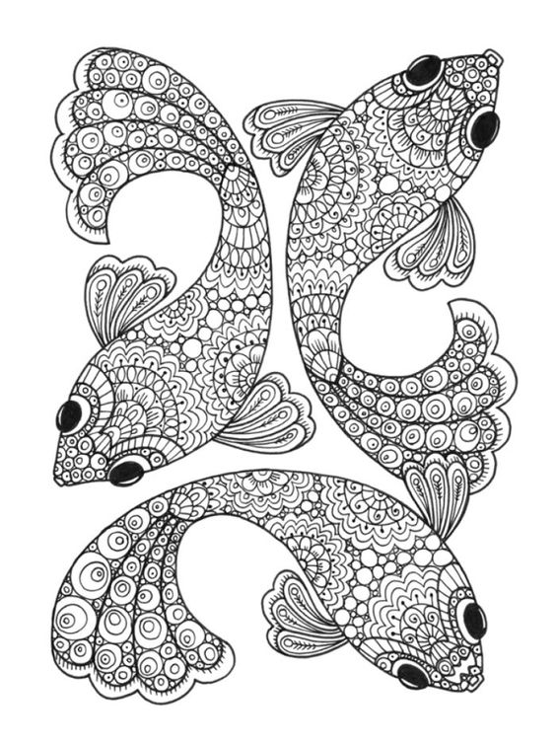
Be Mindful
It can be easy to rush through life without stopping to notice much. Paying more attention to the present moment – to your own thoughts and feelings, and to the world around you – can improve your mental wellbeing.
Some people call this awareness "mindfulness". Mindfulness can help us enjoy life more and understand ourselves better. You can take steps to develop it in your own life.
What is mindfulness?
Professor Mark Williams, former director of the Oxford Mindfulness Centre, says that mindfulness means knowing directly what is going on inside and outside ourselves, moment by moment. "It's easy to stop noticing the world around us. It's also easy to lose touch with the way our bodies are feeling and to end up living 'in our heads' – caught up in our thoughts without stopping to notice how those thoughts are driving our emotions and behaviour," he says.
"An important part of mindfulness is reconnecting with our bodies and the sensations they experience. This means waking up to the sights, sounds, smells and tastes of the present moment. That might be something as simple as the feel of a banister as we walk upstairs.
"Another important part of mindfulness is an awareness of our thoughts and feelings as they happen moment to moment. ”It's about allowing ourselves to see the present moment clearly. When we do that, it can positively change the way we see ourselves and our lives."
How to be more mindful
Reminding yourself to take notice of your thoughts, feelings, body sensations and the world around you is the first step to mindfulness.
Notice the everyday
"Even as we go about our daily lives, we can notice the sensations of things, the food we eat, the air moving past the body as we walk," says Professor Williams. "All this may sound very small, but it has huge power to interrupt the 'autopilot' mode we often engage day to day, and to give us new perspectives on life."
Keep it regular
It can be helpful to pick a regular time – e.g. the morning journey to school – during which you decide to be aware of the sensations created by the world around you.
Try something new
Trying new things, such as sitting at a different table at lunchtime, can also help you notice the world in a new way.
Watch your thoughts
"Some people find it very difficult to practice mindfulness. As soon as they stop what they're doing, lots of thoughts and worries crowd in," says Professor Williams. "It might be useful to remember that mindfulness isn't about making these thoughts go away, but rather about seeing them as mental events.
"Imagine standing at a bus station and seeing 'thought buses' coming and going without having to get on them and be taken away. This can be very hard at first, but with gentle persistence it is possible. "Some people find that it is easier to cope with an over-busy mind if they are doing gentle yoga or walking."
Name thoughts and feelings
To develop an awareness of thoughts and feelings, some people find it helpful to silently name them: "Here’s the thought that I might fail that exam". Or, "This is anxiety".
Free yourself from the past and future
You can practise mindfulness anywhere, but it can be especially helpful to take a mindful approach if you realise that, for several minutes, you have been "trapped" in reliving past problems or "pre-living" future worries.
Year 9 Assessment Week One
Reduce the text to its most difficult idea/concept.
……………………………………………………………………………………………………………………………………………………………………………………………………………………………………
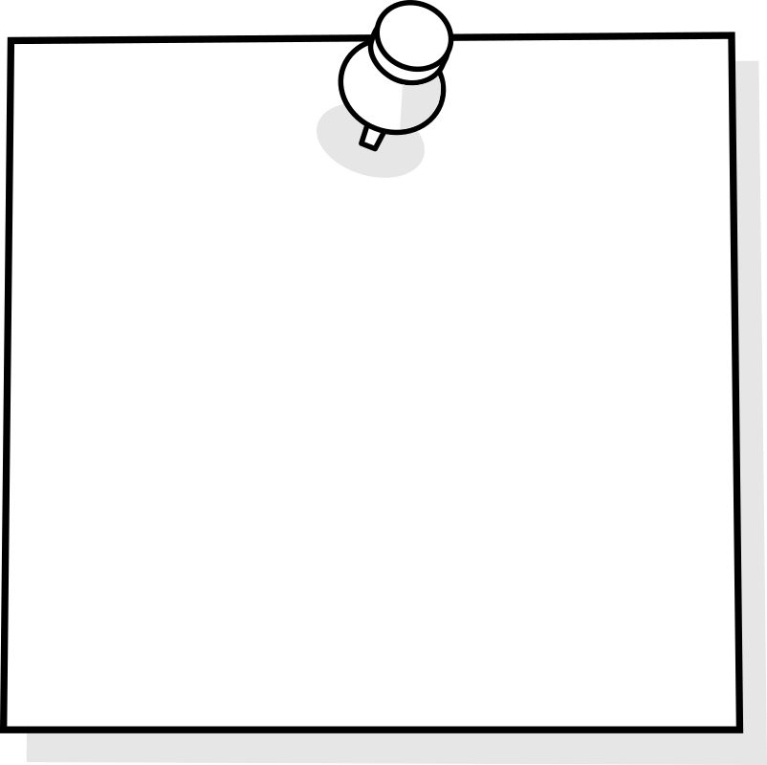
Change the text to a set of four Post-its.

Question yourself. Create three quiz-quiz-trade cards.
Question: |  | Question: |  | Question:
Answer:  Tip: |  | Answer:  Tip: |  | Answer:  Tip:

Practice Page
Try out one or more of the strategies from today’s lesson using a piece of work you will be tested on during assessment week.

Rhino Tinder
The world's most eligible bachelor is coming to Tinder — and he may not be who you expect.
In a new campaign launched on Tuesday, Tinder has partnered with the Ol Pejeta Conservancy in central Kenya to introduce users to Sudan, the last known male northern white rhino in existence. The platform hopes to save Sudan's species from extinction.
As the last hope for all northern white rhinos, 43-year-old Sudan is one of the most protected animals on the planet, surrounded by armed guards at all times. He lives at the conservancy with the only two female northern white rhinos, Najin and Fatu. But he's been unable to breed with Najin and Fatu due to a number of issues, including old age.
Through Sudan's Tinder profile — complete with an adorable profile photo — Tinder and the Ol Pejeta Conservancy hope to raise a hefty $9 million to fund in-vitro fertilisation (IVF) treatment.
Any users who see ads on Tinder could potentially see Sudan the Rhino in their card stack. When users swipe right on Sudan, they'll receive a message that features a link to donate, which would help fund ongoing research focusing on "assisted reproductive technologies."
White rhino populations around the globe have been severely threatened by poaching, with hundreds killed each year by illegal hunters. The animals are killed for their horns, which are traded illegally and used in traditional Asian medicines to treat a range of illnesses. They're particularly vulnerable to poaching because they're relatively unaggressive and travel in herds.
If successful, this would be the first time scientists carry out artificial reproduction in rhinos. They hope to establish a herd of 10 northern white rhinos after five years.

Year 9 Assessment Week Two
Change the text to a timeline.

Question yourself. Ask and answer as many questions as you can about ‘Rhino Tinder’.
……………………………………………………………………………………………………………………………………………………………………………………………………………………………………………………………………………………………………………………………………………………………………………………………………………………………………………………………………………………………………………………………………………………………………………………………………………………………………………………………………………………………………………………………………………………………………………………………………………………………………………………………………………………………………………………………………………………………………………………………………………………………………………………………………………………………………………………………………………………………………………………………………………………………………………………………………………………………………………………………………………………………………………………………………………………………………………………………………………………………………………………………………………………………………………………………………………………………………………………………………………………………………………………………………………………………………………………………………………………………………………………………………………………………………………………………………………………………………………………………………………………………
Compare ‘Rhino Tinder’ to the mark scheme. Decide how easy it is to identify the WHO, WHAT, WHERE, WHEN, WHY and HOW of the story.
 | Easy | Moderate | Difficult
Who is the story about?
What has happened to him?
Where did the event take place?
When did it happen?
Why did it happen?
How did it take place?

Practice Page
Try out one or more of the strategies from today’s lesson using a piece of work you will be tested on during assessment week.

Selfie Culture
Late last year, Instagram star Essena O’Neill “quit Instagram.” She deleted most of her photos, and in the posts that remained, she detailed how fake her Instagram-famous life really was.
“For this photo I hardly ate for a week,” the 19-year-old says in one post. “I bought this bikini just for this photo. I posed for hours until the photo was perfect.”
As a 12 year old, she says she meticulously analysed and obsessed over the beautiful women she saw on social media. “They had all these likes, and all of these views and followers,” she explains. “I thought they would be so happy, surrounded by all these people who love them and appreciate them. I wanted that. I wanted to be valued.
As social media sponsorship opportunities expanded, O’Neill sought that validation. But while all those happy, pretty, empowering selfies showed the image of a happy, pretty, empowering life, they didn’t actually provide one.
Last year, researchers found that the pressure to be active on social media was linked to depression and anxiety in teenagers. “A lot of the scientific work on body image, shows that when people compare themselves to the models they see in media it can influence the way they view themselves.” “When people take on a thin ideal for body image, then they often see themselves as overweight. That can lead to eating disorders like anorexia and bulimia.”
And we can’t run from it; selfies are permeating society from all their many angles. Take, for instance, the fact that Oxford Dictionaries declared selfie to be the Word of the Year in 2013. And last September, a news story comparing the number of shark attack deaths to those who had died in a selfie-related incident went viral. The results? Sharks: 8, selfies: 12. It seemed both outrageous and impossible, but it also seemed like somewhat of a sad metaphor: Is selfie culture not just literally killing us but also killing our body image, our well-being, and our self-worth too?
Year 9 Assessment Week Three
Question yourself. Write out five answers
Answer: …………………………..………….
Question: ………………………………………………………………………………………………....
Answer: …………………………..………….
Question: ………………………………………………………………………………………………....
Answer: …………………………..………….
Question: ………………………………………………………………………………………………....
Answer: …………………………..………….
Question: ………………………………………………………………………………………………....
Answer: …………………………..………….
Question: ………………………………………………………………………………………………....

Compare an abstract concept with the concept in ‘Selfie Culture’.

Retrieve as much information as you can about the three articles we have read this year.
Be Mindful

Rhino Tinder

Selfie Culture

Now check for accuracy. Correct any errors and add any important points that you missed.
Practice Page
Try out one or more of the strategies from today’s lesson using a piece of work you will be tested on during assessment week.

