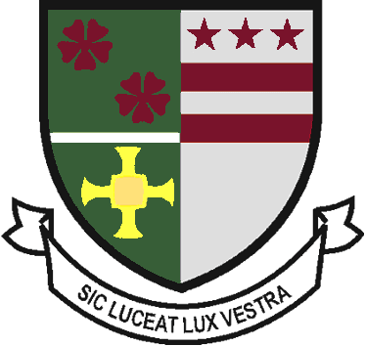
St Robert of Newminster

Catholic School and
Sixth Form College
Biddick Lane, Washington, Tyne & Wear, NE38 8AF
Tel: (0191) 561 3810 Fax: (0191) 415 3801 Email: school@strobertofnewminster.co.uk

Head Teacher: Mr. D. Juric
Chair of Governors: Mr. G. Moorhouse

3rd October 2019

6th Form Open Evening - Thursday 24th October 2019

I would like to invite you and your parents/carers to our 6th Form Open Evening on Thursday 24th October from 5.30pm to 8pm. The evening will be a great opportunity for you to discover the wide variety of courses and enrichment opportunities that are available at St Robert’s 6th Form.

The evening will be based in the Performance Hall where you can discover information on the 34 courses that we offer. You will be able to talk to subject staff about their courses and the possible careers they could lead to. You will also be able to meet 6th Form students who are studying those courses.

The 6th Form team will be available during the evening to answer any questions you may have about the academic and pastoral support we provide. Current 6th Form students will present information about the range of enrichment opportunities on offer.

This is an important evening with a huge amount of information, advice and guidance that will help you make the right choices for you. I hope that you will be able to attend and see for yourself why we are a highly successful 6th Form.

Yours sincerely

Mr D Bayne
Head of 6th Form

Please return to the Student Reception by Friday 18th Oct

6th Form Open Evening – Thursday 24th October 2019

We will/will not be attending the 6th Form Open Evening.

Parent/Carer signature _______________________________________

