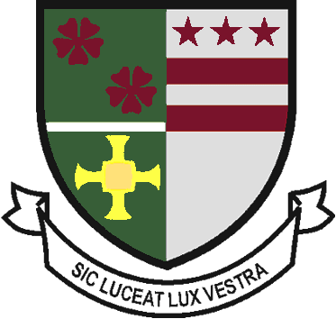
St Robert of Newminster

Catholic School and
Sixth Form College
Biddick Lane, Washington, Tyne & Wear, NE38 8AF
Tel: (0191) 716 1700 Fax: (0191) 415 3801 Email: school@strobertofnewminster.co.uk

Head Teacher: Mr. D. Juric
Chair of Governors: Mr. G. Moorhouse

12th December 2019

Dear Parent/Guardian,

Christmas Fair & Advent Carol Concert

You are warmly welcomed to attend our annual Christmas Fair on Tuesday 17th December from 11:30am to 4:00pm in our Drama Hall. The Fair is supported by the ‘Friends of St Roberts’ and our pupils. If you would like to attend then please arrive at our main reception where our Chaplain, Mr Taylor, will greet you.

In addition, our Advent Carol Concert will take place on Wednesday 18th December from 6:00pm to 7:00pm in our Performance Hall. The concert will include a selection of prayers, carols and music led by our Chaplain and Music Department.

Yours sincerely

Mr A Davis

Assistant Head Teacher & Head of RE

