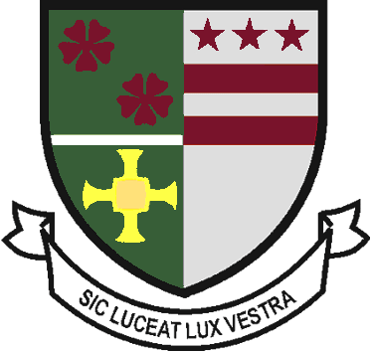
St Robert of Newminster

Catholic School and
Sixth Form College
Biddick Lane, Washington, Tyne & Wear, NE38 8AF
Tel: (0191) 716 1700 Fax: (0191) 415 3801 Email: school@strobertofnewminster.co.uk

Head Teacher: Mr. D. Juric
Chair of Governors: Mr. G. Moorhouse

November 15th 2019

Dear Parent/ Carer,

History Battlefields Visit, 4th July-8th July 2020

Thank you for the deposit of £50 I have received for your child’s place on the History GCSE Battlefields Visit. I am delighted that your child has chosen to attend the trip, it is a fantastic and exciting opportunity for them to broaden their historical knowledge. The next instalment of £100 is due by Friday 6th December. There will be four further instalments to be met; by 24th January 2020 (£100), 28th February 2020 (£100), 27th March 2020 (£100) and the final balance is due by Friday 1st May 2020 (£100). Alternative payment dates can be arranged if necessary but the school must be informed of this. Equally, if you wish to pay the balance in full please feel free to do so.

Payment instructions:
- No cash or cheques will be accepted by the school. All payments must now go through Parent Pay. Your child must come and see me if there is a problem with Parent Pay.
It is essential that your child has a completed medical form and has a valid passport. Some students did not hand in a completed medical form, if you have not already, pleased complete a medical form and return it to school.

The school reserves the right to remove any pupil from the activity at any time if the attitude and behaviour of that pupil does not come up to the high expectations of this school. We monitor student behaviour, achievement and attendance very closely using a points system and this will be used to decide if a pupil can attend a trip or visit.

If you have any questions, please do not hesitate to contact me.

Yours sincerely

Miss J. Bone
Group Leader for the visit
Second in History
Assistant Head of House St Aidan

