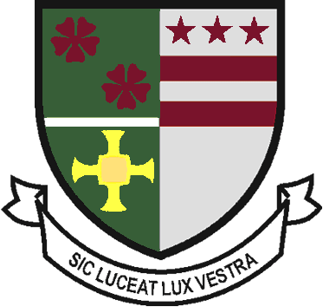
St Robert of Newminster

Catholic School and
Sixth Form College
Biddick Lane, Washington, Tyne & Wear, NE38 8AF
Tel: (0191) 716 1700 Fax: (0191) 415 3801 Email: school@strobertofnewminster.co.uk

Head Teacher: Mr. D. Juric
Chair of Governors: Mr. G. Moorhouse

Dear Parent/Carer. 3rd February 2019

We would like to invite you to a ‘Year 9 Parent/Carer Options Information Evening’ on Thursday 13th February from 5.30pm to 6.00pm.

The session will be an opportunity for you to be given details of the following;

- Student pathways and KS4 curriculum during Years 10 and 11.
- Timeline of the options process.
- Advice & Guidance on areas to discuss with your child.

Following our meeting with parents, we will then notify pupils on the options process via an options assembly. For this reason, students are not required to be present at this presentation.

Please return the following reply slip to the student reception by 3.20pm Friday 7th February stating if you are able/unable to attend the session.

Yours sincerely,

Mr D Mitchell Mrs M Salmon

Timetable & Options Senior Assistant Headteacher
…………………………………………………………………………………………………………

Year 9 Parent/Carer Options Evening (Mr Mitchell) – reply to student office by 7th February

Student Name : …………………………………………. Reg group : ……………………….

I am able / unable (delete as applicable) to attend the ‘Year 9 Parent/Carer Options Information Evening’ on Thursday 13th February.

Signed: …………………………………… Name: (please print)…………………………………………..

