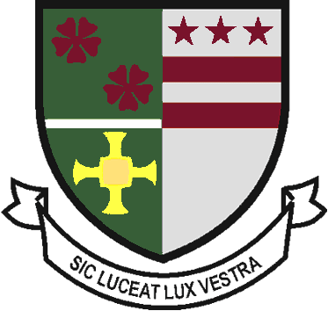
St Robert of Newminster

Catholic School and
Sixth Form College
Biddick Lane, Washington, Tyne & Wear, NE38 8AF
Tel: (0191) 716 1700 Fax: (0191) 415 3801 Email: school@strobertofnewminster.co.uk

Head Teacher: Mr. D. Juric
Chair of Governors: Mr. G. Moorhouse

23rd April 2020

Dear Parents and Carers,

We hope you and your families are well. We have all had to adapt to new ways of working, so I wanted to take the opportunity to say a big thank you for the work you’re doing supporting your child’s wellbeing and learning during this time.

I would like to update you on some changes to the online student work for this term. Students should continue to access their work through the website as normal. One slight difference to the structure of the work is that each teacher, where appropriate, now has a “Lessons” folder specific to their subject. Teachers will upload the student work directly to these folders on a weekly basis. Students should now access their work through the “Lessons” folders set by the teachers who would normally teach them. On the whole, this system has been working well so far. We have been made aware of a few issues here and there, but in the main, I think we have managed to resolve them. However, if you encounter specific issues related to the online work please do contact the school school@strobertofnewminster.co.uk and we will try to work with you on a solution.

During this half-term students will be set tasks that will allow them to receive some feedback from their teachers. This will be conducted in a variety of ways and at different times throughout the term. Within the weekly work students will be provided answer sheets and model answers to help them self-assess their work and check their understanding. Students may be asked to complete a weekly online self-marking quiz, set by their teachers, on the work they have completed. This will give students and teachers immediate feedback on how well they are working. Teachers will set some work online that will allow students to receive specific individual feedback, highlighting the areas students did well and identifying areas to improve. It will be made clear on the weekly learning plans in the ‘Lessons’ folders how students access these specific tasks and when they will receive the feedback.

Please continue to encourage your child to access the work regularly and complete the tasks set by their teachers. This will enable them to receive feedback on certain tasks set throughout the term. If students continue to do their best, then we cannot ask for more than that. Please continue to build in some down time away from their screens and encourage opportunities for daily reading, exercise, relaxation, fresh air and connecting with family and friends.

Many thanks for the support with the online work so far and I wish you and your families well.

Yours faithfully

Mr S Clark
Assistant Head Teacher

