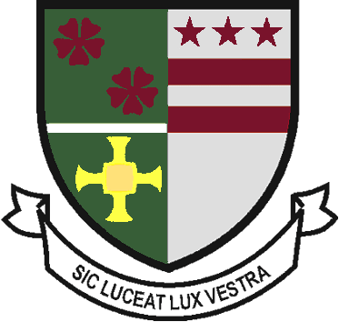
St Robert of Newminster

Catholic School and
Sixth Form College
Biddick Lane, Washington, Tyne & Wear, NE38 8AF
Tel: (0191) 716 1700 Fax: (0191) 415 3801 Email: school@strobertofnewminster.co.uk

Head Teacher: Mr. D. Juric
Chair of Governors: Mr. G. Moorhouse

21 May 2020

Dear Parents and Carers

As ever, I start by saying that I hope you and your families are well, and coping as best you can with the current difficulties. If there is something which you are struggling with, school related or otherwise, please do let us know, and we will try to help if we can.

I hope our young people have been getting on well with their online work. If they are experiencing difficulties accessing work, please do contact the school by email. Over the last few weeks, we have received some emails from parents highlighting a particular schoolwork related problem their son or daughter has been experiencing, and I think, in the main, we have been able to resolve these issues for them. If there is a difficulty, please do let us know. We are aware from log-ons and work submitted that many students are completing all the work set, and most are doing most of it. However, it is clear that a few students are not doing very much schoolwork from the tasks provided. Your son or daughter will have plenty of work to do, and so, if you are aware that he or she is spending very little time each day accessing these exercises, then we do ask you please to encourage them to increase the amount of time they dedicate to these tasks. Tutors are in the process of trying to contact all students in the school by telephone, and as part of a wider general conversation they will also be bringing up the topic of schoolwork. In the vast majority of cases, well done to students for all the work they have done so far and please do keep it up!

The main purpose of my letter is to talk to you about plans for after half term, particularly in the light of government announcements regarding the re-opening of schools to certain year groups. As you will have seen in the media, the government has published non-statutory guidance regarding a wider opening of schools to certain groups of students. Further guidance is expected in the coming days. However, at present, in relation to the secondary sector, the government is encouraging schools to offer some face-to-face support for year 10 and year 12 students from 1st June at the earliest. This guidance is subject to change, and we are informed that the government will review the picture again at the end of May. The guidance currently makes no mention of other year groups.

As a school, we are keen to welcome back students as soon as it is safe to do so, but any decision will have at its heart the safety of students, staff and their families. We do not consider it appropriate at this point for us to begin this re-opening from 1st June, which is, I believe, the stance taken by most secondary schools in the North East. The Directors of the Trust and our Chair of Governors fully support this decision. However, we are in the process of preparing for the reintroduction of groups of Year 10 and 12 students for face to face sessions at some point during June. The school is sending out this week, by text message, a survey for Year 10 and Year 12 parents and carers to gauge their current views on sending their children into school. Please do respond. We are also carrying out a full risk assessment, details of which we will share with parents in advance of any re-opening to aid them in their decision over whether to send their children into school or not. We will give you further information about what form these face to face sessions would take, after half term. Throughout June, online learning will continue for all year groups, regardless of any re-opening. We are endeavouring to develop this further, including a greater level of feedback and interactivity. We plan to supplement this with some additional face to face work, with those year groups identified by the government, but, as stated above, only when we can be satisfied that it is safe for all concerned.

As one final point, the school has remained open daily since lockdown, to the children of key workers and to children identified as vulnerable. This provision will continue during June. If you fall into either of these categories and wish to send your child into school after half term, please contact the school by email for further details. We shall be in contact with those parents and carers already using this provision to ascertain their demand.

I conclude by wishing you all well. I am sure that we will come through these difficult times together. As I stated at the start of my letter, if you are struggling for some reason, please do let us know. I include at the foot of this letter a link to the latest government information for parents and carers regarding educational settings.

Yours faithfully

Mr D Juric
Head Teacher

https://www.gov.uk/government/publications/closure-of-educational-settings-information-for-parents-and-carers

