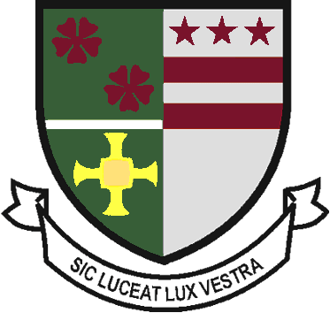
St Robert of Newminster

Catholic School and
Sixth Form College
Biddick Lane, Washington, Tyne & Wear, NE38 8AF
Tel: (0191) 716 1700 Fax: (0191) 415 3801 Email: school@strobertofnewminster.co.uk

Head Teacher: Mr. D. Juric
Chair of Governors: Mr. G. Moorhouse

30th March 2020

Dear Parent/Carer,

We do not have a record of your child’s option form having been returned to school by 20th March 2020. In light of the current circumstances and government advice regarding social distancing, we cannot ask parents or pupils to come to school to hand in their forms in person.

To enable you to respond and provide school with the relevant information, please email the following address, school@strobertofnewminster.co.uk by typing ‘Options’ in the title of the email. In the body of the email response, please include your child’s full name, and their option choices labelling these with a first, second or third choice, as appropriate to the instructions on the form applicable to your child.

The relevant forms for the various pathways are also attached for your reference. With regards to those pupils being offered a ‘personalised pathway’, please do select an option choice from the list available. This pathway can be further discussed upon our return to school.

Please send your email responses by Friday 3rd April. Thank you for your cooperation.

Yours faithfully,

Mrs M A N Salmon
Senior Assistant Headteacher

