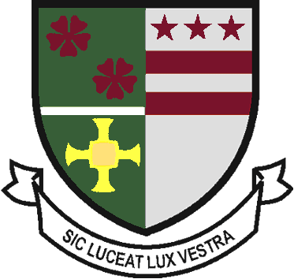
St Robert of Newminster

Catholic School and
Sixth Form College
Biddick Lane, Washington, Tyne & Wear, NE38 8AF
Tel: (0191) 716 1700 Fax: (0191) 415 3801 Email: sixthform@str.bwcet.com

Head Teacher: Mr. D. Juric
Chair of Governors: Mr. G. Moorhouse

24th August 2020

Dear Students

Autumn Exams 2020

As you are aware, Year 13 students do have the opportunity to sit their A level exams this autumn, if they are unhappy with their current grade and wish to try to improve upon it.

As yet exact dates have not been released to schools, but we have been informed that A level exams will take place between 5th and 23rd October. If you wish to sit any of your A level subjects in October (or English or Mathematics GCSE), please email Autumn2020Exams@str.bwcet.com by 9:30am 1st September, giving your name and exact details of which qualifications you wish to sit. The school will cover the cost of examination fees. However, if, without good reason, a student misses the entry deadline or enters for the exam and then fails to sit it, then the student will be invoiced for any unnecessary costs incurred.

If you wish to discuss your decision first, please email me at sixthform@str.bwcet.com

Yours faithfully,

Mr D Bayne
Head of 6th Form

