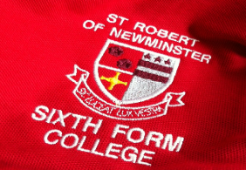
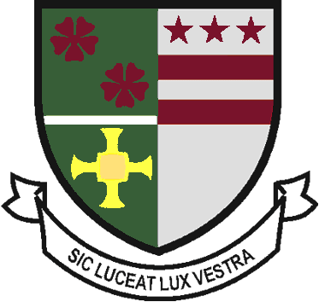
Sixth Form Uniform Order
2020-2021

Student Name : | Contact number :

Payments - CASH or CHEQUE - made payable to - Bishop Wilkinson CET

* Payments to be made before uniform issued.

Sixth Form Polo Shirt - £15.00
X SMALL | SMALL | MEDIUM | LARGE | X LARGE | XX LARGE | TOTAL
 |  |  |  |  |  | £

Sixth Form Hoodie - £20.00
X SMALL | SMALL | MEDIUM | LARGE | X LARGE | XX LARGE | TOTAL
 |  |  |  |  |  | £

Sixth Form Rugby Shirt - £20.00
X SMALL | SMALL | MEDIUM | LARGE | X LARGE | XX LARGE | TOTAL
 |  |  |  |  |  | £

Sixth Form Cardigan - (Pre order only) £18.00
Male | X SMALL | SMALL | MEDIUM | LARGE | X LARGE | XX LARGE | TOTAL
 |  |  |  |  |  |  | £
Female | SIZE 6 | SIZE 8 | SIZE 10 | SIZE 12 | SIZE 14 | SIZE 16 | TOTAL
 |  |  |  |  |  |  | £

Sixth Form Black Jumper - (pre order only) £18.00
Male | X SMALL | SMALL | MEDIUM | LARGE | X LARGE | XX LARGE | TOTAL
 |  |  |  |  |  |  | £
Female | SIZE 6 | SIZE 8 | SIZE 10 | SIZE 12 | SIZE 14 | SIZE 16 | TOTAL
 |  |  |  |  |  |  | £

Please return to - Sixth Form Admin, St Robert of Newminster School & Sixth Form College, Biddick Lane, Washington, Sunderland, Tyne and Wear, NE38 8AF or Sixthform@strobertofnewminster.co.uk

Office use only – Total Amount paid Cash / Cheque
£

