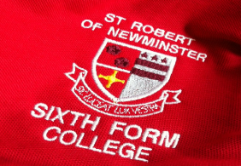
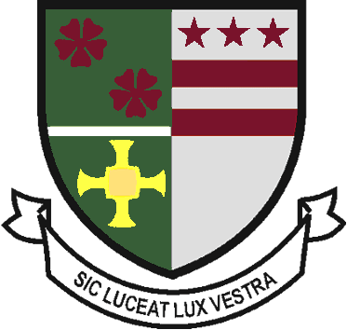
Sixth Form Uniform Order
2021-2022

Student Name : | Contact number :

Payments –Parent Pay, CASH or CHEQUE - made payable to - Bishop Wilkinson CET
* Payments to be made before uniform issued.

Sixth Form Polo Shirt - £15.00
X SMALL | SMALL | MEDIUM | LARGE | X LARGE | XX LARGE | TOTAL
 |  |  |  |  |  | £

Sixth Form Hoodie - £20.00
X SMALL | SMALL | MEDIUM | LARGE | X LARGE | XX LARGE | TOTAL
 |  |  |  |  |  | £

Sixth Form Rugby Shirt - £20.00
X SMALL | SMALL | MEDIUM | LARGE | X LARGE | XX LARGE | TOTAL
 |  |  |  |  |  | £

Sixth Form Cardigan - (Pre order only) £23.00
Female | SIZE 8- 33" | SIZE 10- 35" | SIZE 12- 37" | SIZE 14 -39" | SIZE 16- 41" | SIZE 18 -43" | TOTAL
 |  |  |  |  |  |  | £

Sixth Form V Neck Black Jumper - (pre order only) £23.00
Chest (to fit) | 30" | 34" | 38" | 42" | 46" | 50" | TOTAL
 |  |  |  |  |  |  | £

Sixth Form Crew Neck Black Jumper - (pre order only) £23.00
Chest (to fit) | 30" | 34" | 38" | 42" | 46" | 50" | TOTAL
 |  |  |  |  |  |  | £

Please return to - Sixth Form Admin, St Robert of Newminster School & Sixth Form College, Biddick Lane, Washington, Sunderland, Tyne and Wear, NE38 8AF or sixthform@str.bwcet.com

Office use only – Total Amount paid Cash / Cheque/ Parent pay
£

