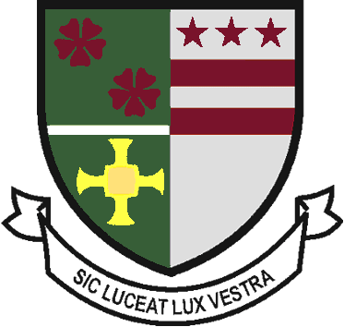
St Robert of Newminster

Catholic School and
Sixth Form College
Biddick Lane, Washington, Tyne & Wear, NE38 8AF
Tel: (0191) 716 1700 Email: school@str.bwcet.com

Head Teacher: Mr. D. Juric
Chair of Governors: Mr. G. Moorhouse

29 September 2022

Dear Parent/Carers

Further to our recent Year 10 and Year 11 parent information evenings I would like to share some further details about how to use and access GCSE pod. Students will also be having an assembly on GCSE pod next week to share the same information and guide them through how to create/re-activate their accounts.

What is GCSE pod?
GCSE pod is an online learning platform that gives students access to video clips known as “pods”, multiple choice quizzes, past exam questions, GCSE to A level bridging work and more. It covers over 28 GCSE subjects and a variety of exam boards, enabling students to access additional support and exam boards that they study. GCSE pod also allows teachers to set students specific assignments and homework tasks and to monitor their progress on these. It can be accessed online through their website www.gcsepod.com or via the GCSE pod app.

Year 11 Students:
All students in year 11 have a GCSE pod account and should follow the instructions below to log in. Students should check their GCSE pod accounts regularly.
- Go to https://members.gcsepod.com/login/
- Enter their username or school email address and then a password
- If a student has forgotten their log in details, they should click ‘forgotten my log in details’ and enter their recovery email address. If this is unsuccessful, they should speak to their Form Tutor or Miss Evans (Lead Teacher for GCSE Pod).

Year 10 Students:
Year 10 students will need to register their GCSE pod account before their first use. They do so by following the steps below.
- Go to https://members.gcsepod.com/login/
- Click on ‘New to GCSE Pod Get Starter’
- Select ‘Student’
- Students must enter their forename, surname, and date of birth.
- Students should then enter St Robert of Newminster as their school. This should appear as a drop-down option as they do.
- Students will then be taken through a series of steps which will enable them to enter a username, password and recovery email. They will also be able to select their subjects, making their homepage specific to their GCSE subjects.

Links that might be useful:

- This link has a clip aimed at informing parents on how to support students with GCSE Pod.
- This link is to the log in page.

Parents Information Evening Links:
- A link to our recent Year 10 and Year 11 Parents Information Evenings can be found by clicking here.
- A link to a subject-by-subject GCSE revision guide can be found by clicking here.

Many thanks for your continued support.

Yours Faithfully

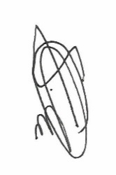
Mr Clark

Assistant Head Teacher

